INTERNATIONAL CONFERENCE ON HEALTH AND

DISEASE MANAGEMENT (ICHDM 2026)

HOSTED BY

SASTRA DEEMED TO BE UNIVERSITY, KUMBAKONAM.

TITLE

A Blockchain-Enabled Machine Learning Framework for

Accurate Glucose Detection in Healthcare

AUTHORS

Surya Prabha R, Abhirami S, Venkatesan R, Ithaya Priya B

SUPERVISOR

VENKATESAN R

ASSOCIATE PROFESSOR

DEPARTMENT OF BIOMEDICAL ENGINEERING

Batch No: T953

Mode: Offline

Venue: 201 (Second Floor)

Session & Time: II & 3:30 PM-5:30 PM

A Blockchain-Enabled Machine Learning Framework for Accurate Glucose Detection in Healthcare
Ithaya Priya B¹, Surya Prabha R^{2*}, Abhirami S², Venkatesan²
¹Department of Computer Science and Engineering, E.G.S. Pillay Engineering College, Nagapattinam, Tamil Nadu, India – 611002
²Department of Biomedical Engineering, E.G.S. Pillay Engineering College, Nagapattinam, Tamil Nadu, India – 611002
Corresponding author email id: vengatesan.r@egspec.org

Abstract
Effective glucose monitoring is essential for the early detection and management of diabetes, particularly in smart healthcare environments that rely on real-time data and connected medical devices. This paper presents a secure and intelligent glucose detection framework that integrates advanced machine learning techniques with blockchain technology to ensure both predictive accuracy and data security. The proposed system leverages multi-source data, including the PIMA Indian Diabetes dataset, Continuous Glucose Monitoring (CGM) readings, and physiological parameters obtained from wearable sensors, enabling comprehensive and personalized glucose prediction.
To enhance data quality, preprocessing steps such as normalization, outlier removal, and class imbalance correction using Borderline-SMOTE are applied. Feature engineering combines clinically relevant attributes with latent representations extracted through a deep autoencoder, followed by optimal feature selection using Support Vector Machine Recursive Feature Elimination (SVM-RFE). An optimized Extreme Gradient Boosting (XGBoost) model is then employed for glucose level prediction, demonstrating high accuracy and robustness. To improve clinical trust and transparency, SHAP (SHapley Additive exPlanations) is used to interpret model decisions.
To address critical concerns related to healthcare data privacy and integrity, a blockchain-based architecture is incorporated. Ethereum smart contracts, SHA-256 hashing, and AES-256 encryption collectively ensure secure, tamper-resistant, and auditable storage of medical data. The proposed framework offers a scalable, trustworthy, and explainable solution for next-generation intelligent glucose monitoring systems in smart healthcare.
Keywords
Glucose Prediction, Smart Healthcare, Machine Learning, XGBoost, Blockchain, Explainable AI, SHAP, Wearable Sensors, Continuous Glucose Monitoring, Healthcare Data Security

ICHDM - 2026 Registration Confirmation

ICHDM 2026 SASTRA <ichdm2026@sastra.ac.in> | Fri 6 Feb, 17:01
to me

Dear R. Surya Prabha,
Thank you for registering for the “International Conference on Health and Disease Management” (ICHDM-2026), to be held on February 26th and 27th, 2026, under the Oral Presentation category. Your Unique ID: T953. Kindly join the WhatsApp group through this link:https://chat.whatsapp.com/JbIdU4dRXhILSMyEYFBsfb

Regards,
Organizing Team
ICHDM-2026

TRANSACTION DETAILS:

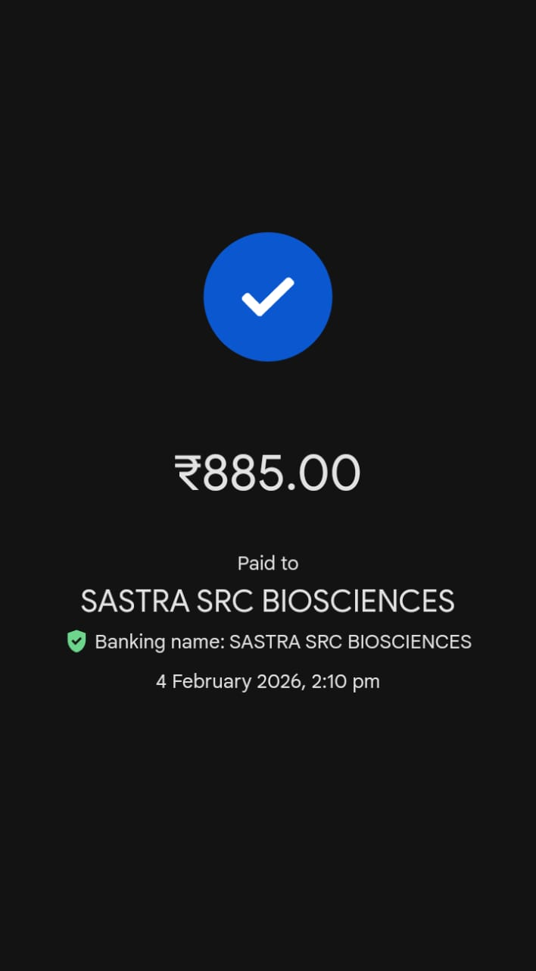

PRESENTATION @ ICHDM 2026

